

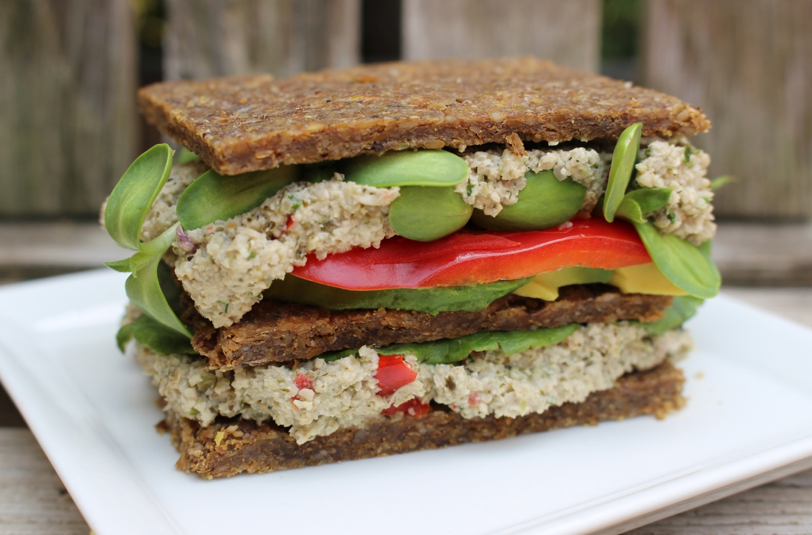
When I was young, and on into my teenage and college years, I enjoyed eating tuna sandwiches, and never gave a thought to mercury poisoning or to the mercury content of fish in general. Alot has changed since my teen years, and mercury concern is one of them.
Today, I still enjoy my tuna salad/pate, but of course eat the raw version of it. I enjoy it in wraps, spread on crackers, or dolloped onto a green salad. If this is your first time, you are in for a pleasant surprise. Our not tuna, mock tuna pate is a big hit.
After you’ve enjoyed making and eating up, come back and let me know how you’ve used it.

Mock Tuna Salad / Pate
Equipment needed: Food Processor
Ingredients:
- 1 1/4 cups sunflower seeds, soaked for 4-6 hours
- 1/4 cup chopped red pepper
- 3 stalks of celery, chopped into small pieces
- 1/4 cup red onion, chopped into small pieces or minced
- 1/4 cup fresh parsley, minced
- 3 tablespoons lemon juice
- 1 tablespoon fresh dill, minced or 1 teaspoon dill seasoning
- 2 teaspoons Tahini
- 2 teaspoons kelp powder
- 1/2 teaspoon Himalayan salt (or to taste)
- 1/4 cup water, if needed
Preparation Steps:
1. Place sunflower seeds in food processor, outfitted with ‘S’ blade, and break down into meal consistency
2. Add Tahini, lemon juice, kelp powder, salt, celery, onion and red pepper and mix and pulse well together. Its okay to see red flakes of red pepper.
3. Add parsley and dill and pulse into mixture
Anytime during the mixing process, you feel it needs water, feel free to add small amounts at a time.
4. Serve in wraps, with crackers, crudities, or as filling in tortillas.
